Horriya Noor

Sap Id: 64048
Department: BSCS
Semester: 4th
Computer Architecture
Lab Task # 3
Topic: Addition

Task # 1:
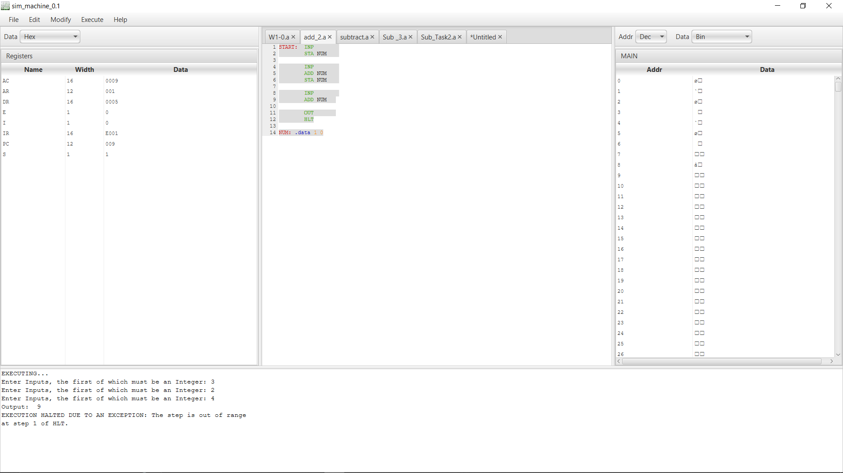
Accept three numbers as input and compute their sum.

Task # 2:
Add a Number to Itself (Double a Value)

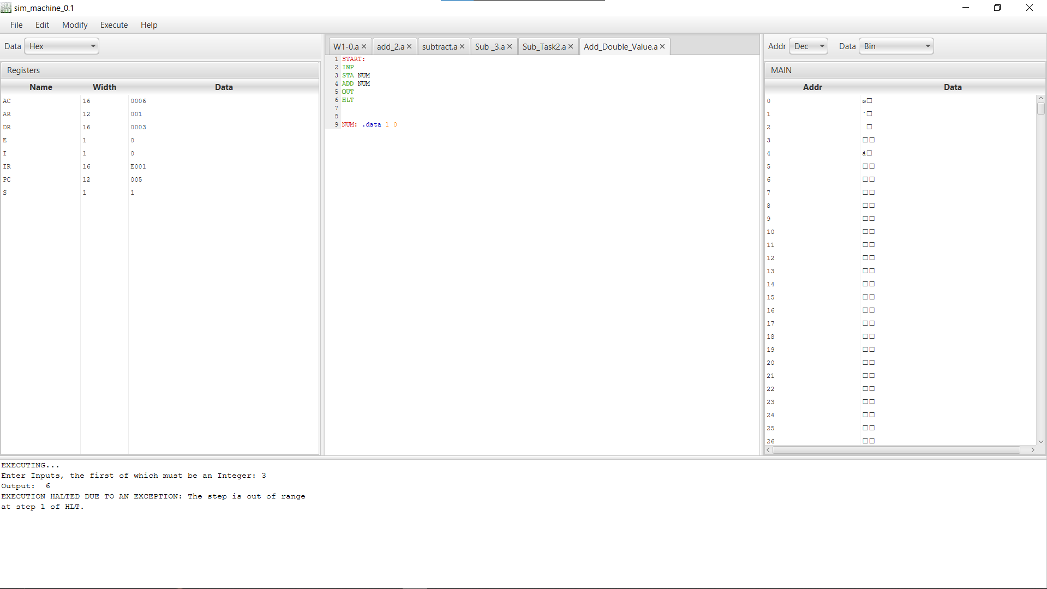
Topic: Subtraction

TASK # 1:
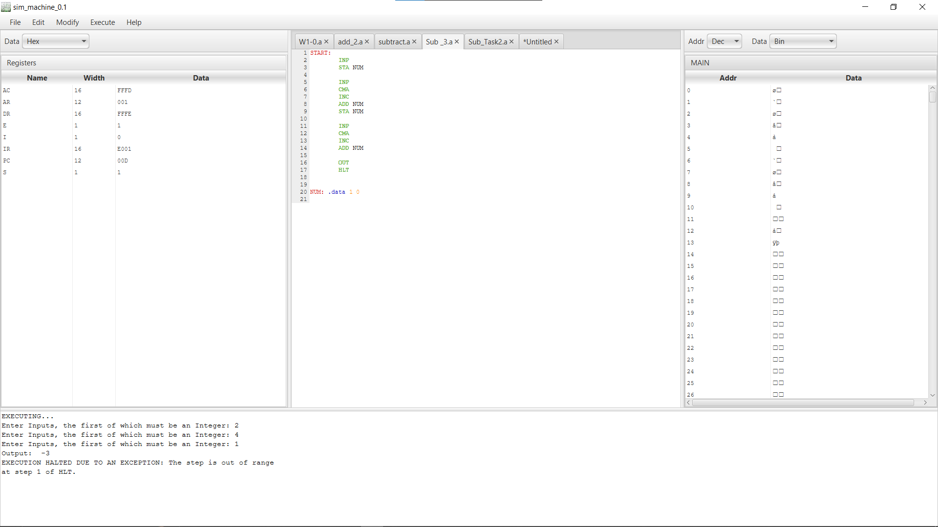
Accept three numbers as input and subtract them.
Task # 2:
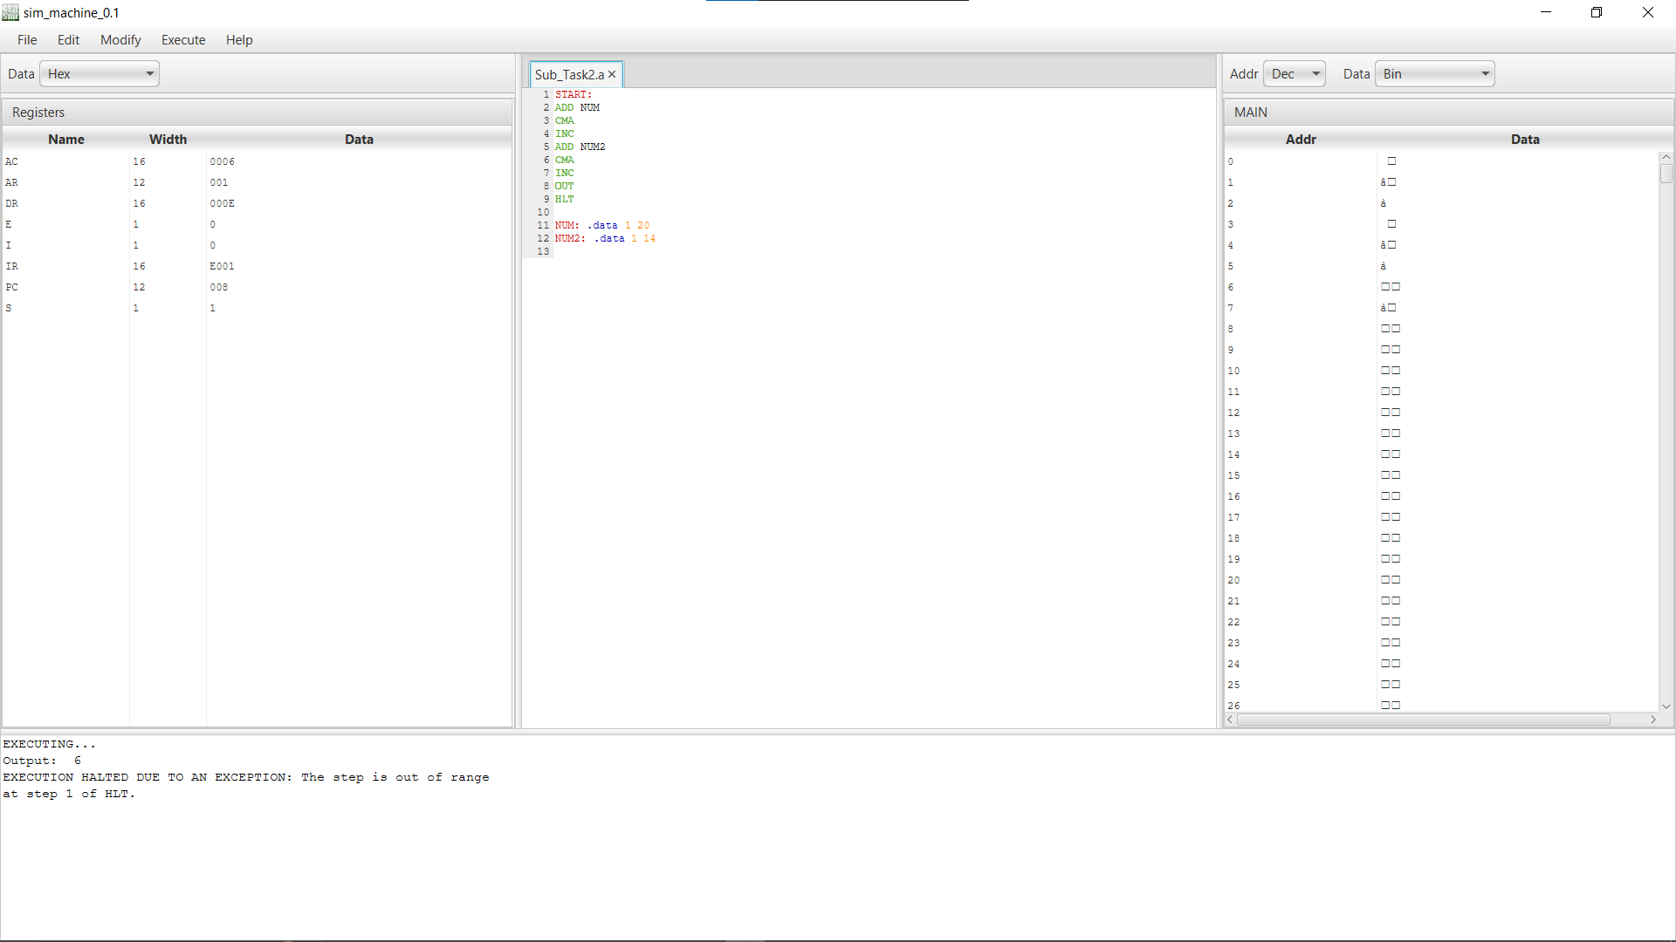
Subtract Two Numbers Stored in Memory (Predefined Values).

